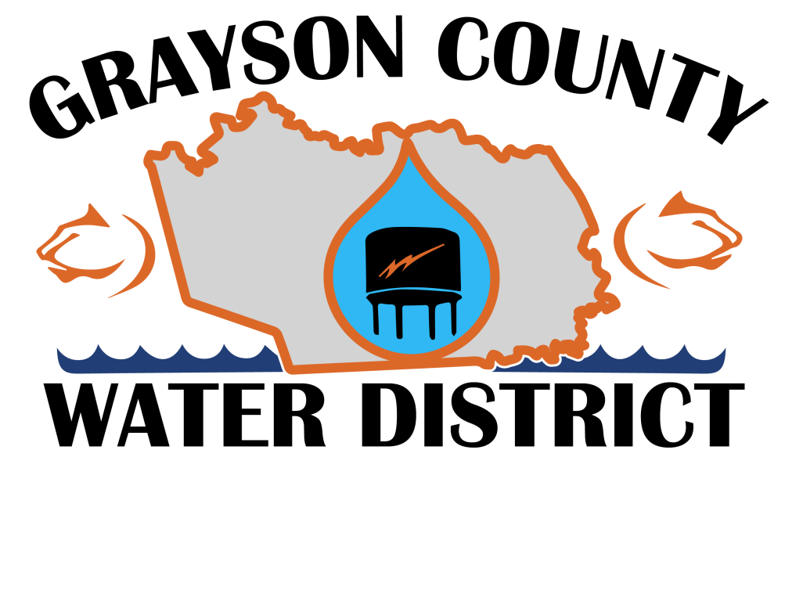 |  | GCWD  - Newsletter  - September 1st, 2017

updates and changes

In October of 2016 the Grayson County Water District was informed by Warren Rural Electric that they would be terminating the operating agreement with the District. Since that time the Board Members, Management, and the employees of the District have been working diligently to continue to provide our customers with the quality water and quality customer service. Our hope has been that our customers have seen only small changes up to this point. Unfortunately, several changes will be coming over the course of the next few months. It is our intention to try and make these changes as painless as possible.
Please see the changes below and feel free to contact us via phone at (270) 259-2917 or via email at gcwd@graysonwater.com.
PAYING YOUR BILLS
Customers will continue to pay their bills by all of the same methods that they have over the last several years with some minor changes.
- Customers will continue to pay in the office, currently located at 113 S. Lee Ave in Leitchfield. However, customers WILL NOT be able to pay their water bill at the front counter or at the drive thru. Water District customers WILL enter through the new Water District entrance to pay their bills.
- Customers will be able to pay via the internet at our website, www.graysonwater.com.
- The District will still accept Visa and Master Cards and will be able to accept Discover.
- If you are accustomed to paying your bill over the phone, that option will also continue to be available. The phone number will change and we hope to have that number available very soon.
- Customers that currently use the online bill pay feature through their bank will need to update their account with our new mailing address, 21 Shull White Road, Leitchfield, KY 42754.
- There will be no change for any customer currently using bank draft. However, any customer currently paying via credit card draft will have to set their account up again after November 1st.

BILLING INVOICES
Customers of the Water District will also see some slight changes to their bills around November 2017. Most of the same information will be provided with some slight changes in layout and appearance. If you have any questions about the bill just give us a call.
WE’RE MOVING
The Water District is currently located at 113 S. Lee Ave, Leitchfield, KY in the Warren RECC Building. Our new facility is currently under construction and is located at 21 Shull White Rd., Leitchfield, KY 42754. The District plans to relocate to the new facility sometime after the first of the year.. Any mail, payments, or correspondence should be sent to our new address.
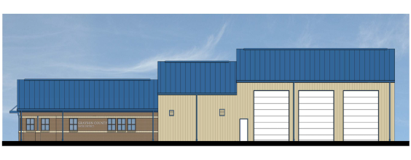

Changes are Coming

